- Tên và phân loại:

- Mục đích, ý nghĩa:
- Allow an object to alter its behavior when its internal state
changes. The object will appear to change its class
- Động lực sử dụng:
- Consider a class TCPConnection that represents a network
connection. A TCPConnection object can be in one of several
different states: Established, Listening, Closed. Its response to a request
from another object depends on its current state
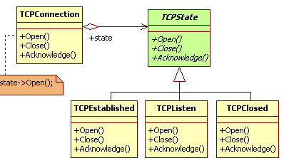
- Khi nào sử dụng:
- An object's behavior depends on its state, and it must change
its behavior at run-time depending on that state
- Operations have large, multipart conditional statements that
depend on the object's state
• This state is usually represented by one or more enumerated
constants
• Often, several operations will contain this same conditional
structure
• The State pattern puts each branch of the conditional in a
separate class. This lets you treat the object's state as an object in
its own right that can vary independently from other objects
- Cấu trúc
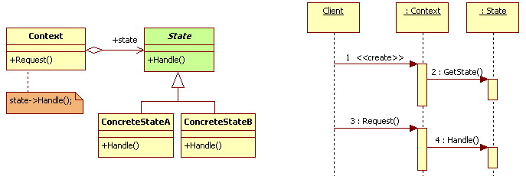
- Các thành viên - Sự cộng tác
- Context
• Defines the interface of interest to clients
• Maintains an instance of a ConcreteState subclass that defines
the current state
- State: defines an interface for encapsulating the behavior
associated with a particular state of the Context
- ConcreteState: each subclass implements a behavior
associated with a state of the Context
- Các hệ quả mang lại:
- Localizes state-specific behavior and partitions behavior for different
states
• Puts all behavior associated with a particular state into one object
• Because all state-specific code lives in a State subclass, new states and
transitions can be added easily by defining new subclasses
- Makes state transitions explicit
• When an object defines its current state solely in terms of internal data
values, its state transitions have no explicit representation; they only show
up as assignments to some variables
• Introducing separate objects for different states makes the transitions
more explicit
• State objects can protect the Context from inconsistent internal states,
because state transitions are atomic from the Context's perspective – they
happen by rebinding one variable (the Context's State object variable),
not several
- State objects can be shared
• If State objects have no instance variables – that is, the state they
represent is encoded entirely in their type – then contexts can share a
State object
• When states are shared in this way, they are essentially flyweights with no
intrinsic state, only behavior
- Chú ý liên quan đến cài đặt:

- Hệ thống thực tế

- Mẫu liên quan
- The Flyweight pattern explains when and how State objects
can be shared
- State objects are often Singletons

